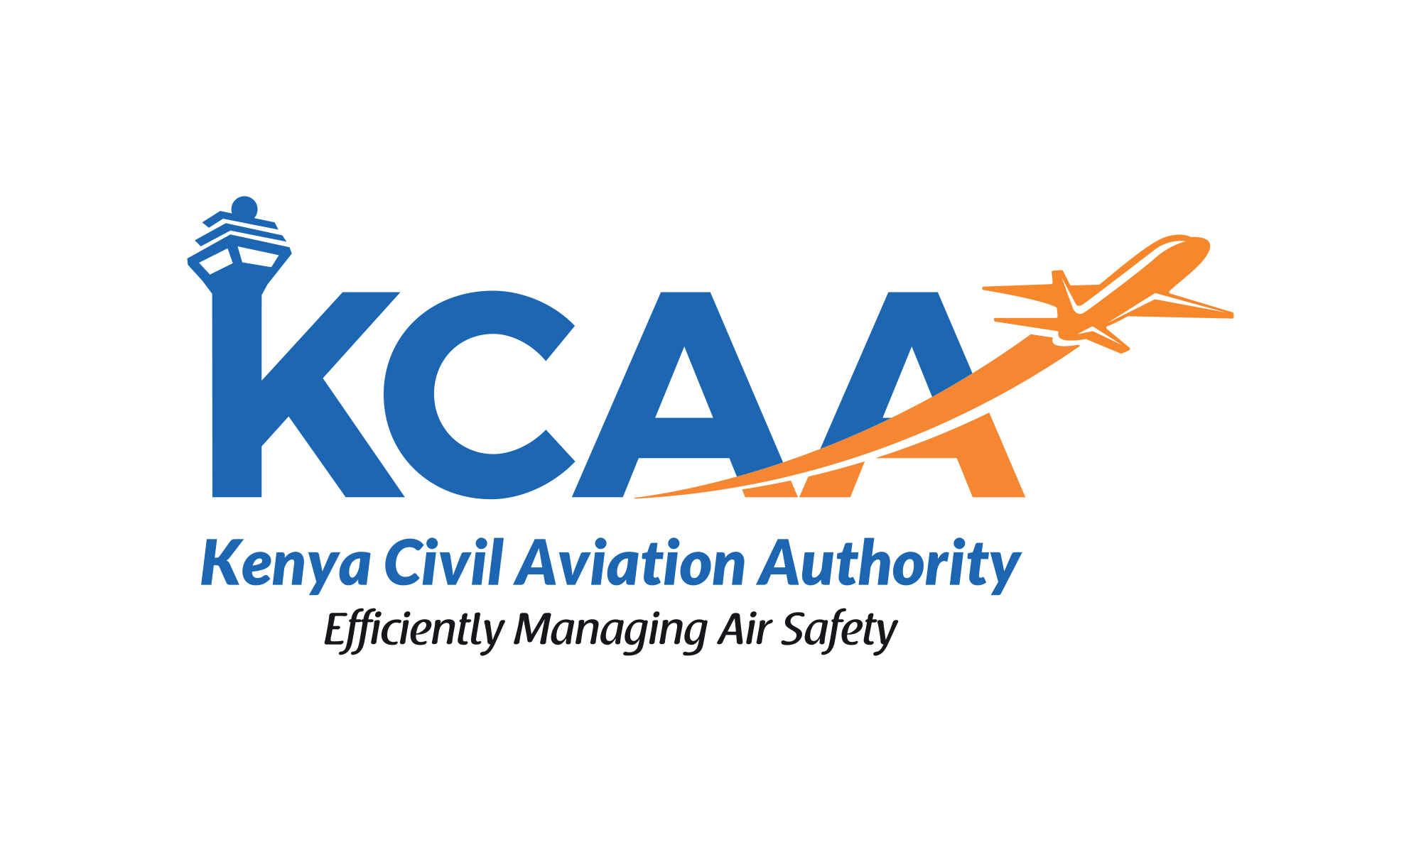 | FORM  FORM:AC-OPS001-4  November, 2024
APPLICATION FOR AMENDMENT OF AN AIR OPERATOR CERTIFICATE

This form contains the process and information for the Application for amendment of AOC and its associated Operations Specifications. Completion and submission of this form by the applicant constitutes a request to amend the current AOC and Operations Specification. Reference should be made to guidance material CAA-AC-OPS001 as amended.

The Pre-Application Statement of Intent (PASI) application form: AC-OPS001 as amended should be filled and submitted together with this form.

Air Operator Certificate Amendment Job Aid and Schedule of Events Minor Amendment Form (FORM:AC-OPS001-4) and Air Operator Certificate Amendment Job Aid and Schedule of Events Major Amendment Form (FORM:AC-OPS001-5) is to be used as to assist the AOC holders in their compliance with the applicable requirements pertaining to the amendment.

1. OPERATOR DETAILS
Name of Operator: |  |  |  |  |  |  |  | AOC No:
Name of the Contact Person and Designation |  |  |  |  | Tel: |  |  | Email:
2. AMENDMENT DETAILS
Changes in Particulars of Organization (Name, Trading Name, Address, etc)
New Name of the Organization:
New or Additional Trading Name:
Change new address:
 |  |  | Telephone: |  |  |  |  | Email:
Change / Add Main Base:
Addition of Aircraft: |  | Aircraft Registration: |  |  |  |  | Aircraft Type:
 |  | New aircraft type (not already operated by the AOC Holder)
Inclusion of Aircraft: |  | Aircraft Registration: |  |  |  |  | Aircraft Type: |  |  | Variant:
Aircraft Inclusion of a variant aircraft to an existing fleet of that aircraft type; or

Aircraft Inclusion of the same variant aircraft to an existing fleet of that aircraft type
Removal of Aircraft: |  | Aircraft  Registration: |  |  |  |  | Aircraft Type:
 |  | Aircraft  Registration: |  |  |  |  | Aircraft Type:

Change to Operation Specifications: |  | Type of Operation: |  |  | Passenger  Cargo  Others (Specify)
 |  | Specific Approvals: |  |  | Performance Based Operations (PBN)  RVSM  NAT HLA  ASEPTA  All Weather Operations (AWO)  EFB  PBCS  CPDLC/ADS-C  ADS-B  EDTO  Dangerous Goods
 |  | Areas of Operation: | Removal of Areas Addition of Areas
 |  | Areas of Operation: | Details:
Change in Other*: |  | Description of amendment:
If any other amendment is required, please contact KCAA to discuss your amendment process.
LEVEL OF COMPLEXITY OF DIFFERENCES
- The AOC holder’s evaluation team will determine, for each element of the evaluation checklist, the complexity level assigned to that element from the following listing—
Level | Description | Tick as applicable
Level 0 | No document revision or personnel briefing or training required.
Level 1 | Document revision required, but no personnel briefing or training required
Level 2 | Document revision required and personnel briefings required to ensure workforce understand differences
Level 3 | Document revision required and formal ground training required to ensure workforce understand complexity of differences
Level 4 | Document revision required, formal ground training required and flight training required to ensure pilots are aware of specific flight characteristics
Note:
- If all of the complexity levels are determined to be 1 or 2 only, the application process will be limited to the evaluation of the submitted documents and observation of briefing.
- If any of the complexity levels are determined to be 3 or 4, the formal application process is required.
- The extent of the process will be determined by KCAA by applying the submission requirements of the Advisory Circular CAA-AC-OPS001 as amended
- The completed evaluation checklist with a complexity level assigned to each element in Appendix A must be formally provided to the KCAA with this Application Form.

3. SCHEDULE OF EVENTS
Proposed commencement date of operation (if applicable):
4. APPLICANT’S DECLARATION
I hereby apply for a variation to the Air Operator Certificate and declare that, to the best of my knowledge and belief, the statements given in this application are true.
Date:
Name of Accountable Manager: |  |  | Signature of Accountable Manager:

APPENDIX A

Evaluation of the AOC Amendment Level of Complexities of the Differences

COMPLETE THIS CHECKLIST FOR AIRCRAFT ADDITION/ INCLUSION TO ADD/ INCLUDE THE AIRCRAFT TO THE AOC HOLDER’S FLEET FOR KCAA EVALUATION TO DETERMINE THE LEVEL OF COMPLEXITY OF THE DIFFERENCES.
AIRCRAFT MAKE, MODEL: ___________________________

REGISTRATION: _________________________ SERIAL NO: __________________
DATE: | COMPLETED BY:
- For each subject area, check NO if there are no differences between this aircraft and the existing AOC holder’s fleet of this make and model.
- For each subject area, check YES if there is a difference between this aircraft and the existing AOC holder fleet of this make and model.
- For each element, enter the complexity level of differences in the LEVEL column
- In the DOC REVISIONS column, enter the manual and chapter or paragraph where revisions will be made to accommodate the addition/inclusion of this aircraft in the AOC holder’s fleet of this make and model.

Level | Description
Level 0 | No document revision or personnel briefing or training required.
Level 1 | Document revision required, but no personnel briefing or training required
Level 2 | Document revision required and personnel briefings required to ensure workforce understand differences
Level 3 | Document revision required and formal ground training required to ensure workforce understand complexity of differences
Level 4 | Document revision required, formal ground training required and flight training required to ensure pilots are aware of specific flight characteristics
Note:
- If all of the complexity levels are determined to be 1 or 2 only, the application process will be limited to the evaluation of the submitted documents and observation of briefing.
- If any of the complexity levels are determined to be 3 or 4, the formal application process is required.
- The extent of the process will be determined by KCAA by applying the submission requirements of the Advisory Circular CAA-AC-OPS001 as amended.
1 | FLIGHT DECK | YES | NO | NA | LEVEL | DOC REVISION
1.1 | Flight Management System Presentation and Operation
1.2 | Primary Flight Guidance Presentation and Operation
1.3 | Other Instrumentation Location and Marking?
1.4 | Other Switch Location and Operation
1.5 | Warning Indications and Sounds Presentation?
1.6 | Circuit Breaker Location
1.7 | Communications Equipment
2 | CRITICAL INFORMATION | YES | NO | NA | LEVEL | DOC REVISION
2.1 | Instrument Approach Mini-  mums
2.2 | Passenger Information Cards
2.3 | Condensed Checklists
2.4 | Expanded Checklists
2.5 | Aircraft Limitations
2.6 | Aircraft Performance
2.7 | Aircraft Weight and Balance
2.8 | Weight and Balance Computations
2.9 | Operational Flight Plan Computations
2.10 | Aircraft Operation Manual
2.11 | Minimum Equipment List (Installation & Dispatch)
2.12 | Training Programme or Syllabi
2.13 | Operational Bulletin
2.14 | Maintenance Program
2.15 | Main Program Bridging Doc
2.16 | Reliability Program
2.17 | Engine Condition Monitoring
2.18 | Illustrated Parts Catalog
3 | AIRCRAFT SYSTEMS | YES | NO | NA | LEVEL | DOC REVISION
3.1 | Aircraft General
3.2 | Air Conditioning and Pressurization
3.4 | Automatic Pilot
3.5 | APU
3.6 | Electrical
3.7 | Emergency Equipment Location and Use
3.8 | Powerplant
3.9 | Fire Protection
3.10 | Flight Controls
3.11 | Fuel
3.12 | Hydraulics
3.13 | Ice & Rain Protection
3.14 | Instrumentation and
3.15 | Landing Gear
3.16 | Navigation

