APPLICATION FOR ISSUE / RENEWAL OF A CERTIFICATE AIRWORTHINESS |  |  |  | INSTRUCTIONS - Print or type. Submit original only to the Authority. If additional space is required use an attachment.
I. AIRCRAFT DESCRIPTION | 1. NAME OF AIRCRAFT OWNER |  |  | 2. ADDRESS OF OWNER
 | 3. NATIONALITY |  |  | 4. NAME AND ADDRESS OF OPERATOR
 | 5. MANUFACTURER |  |  | 6. YEAR OF MANUFACTURE
 | 7. STATE OF DESIGN |  |  | 8. REGISTRATION MARKS
 | 9. DESCRIPTION OF AIRCRAFT: | (a) New or Used |  | (b) Type |  |  | (c) Series
 | 9. DESCRIPTION OF AIRCRAFT: | (d) Manufacturer’s Serial Number |  | (e) Type of Engine |  |  | (f) Number of Engines fitted
 | 9. DESCRIPTION OF AIRCRAFT: | (g) Type of Propeller (where applicable): |  | (h) Seating accommodation (including crew): |  |  | (i) Avionics installed: (  attach equipment Form)
 | 10. MAXIMUM TAKE-OFF MASS OF AIRCRAFT |  |  | 11. Noise Certification meets appropriate Provisions of AIW CARs  Yes NO (attach certificate)
II. PARTCULERS OF THE  C OF A | 12. DETAILS OF CURRENT CERTIFICATE OF AIRWORTHINESS |  | (a) State of Origin of Certificate |  |  | (b) Number of the Certificate
 |  |  | (c) Type of Certificate (Normal or export) |  |  | (d) Date of Issue of Certificate
 | 13. DETAILS OF CERTIFICATE APPLIED FO R |  | (a) Commercial Air Transport (passengers) |  | (b) Commercial Air Transport (Cargo) |  |  | (c) Aerial work
 |  |  | (d) General Aviation |  | (f) Special Operations (specify)
 | 14. Renewal Only: Hours flown since C of A issue or last renewal: hours flying
 | 15. NAME AND ADDRESS OF APPROVED ORGANIZATION/LICENSED AIRCRAFT MAINTENANCE PERSONNEL WITH WHOM AIRCRAFT IS AVAILABLE FOR INSPECTION
I hereby declare that the particulars entered on this application and its appendices are accurate in every respect and the aircraft mentioned above complies with all Regulatory Requirements for ISSUE / RENEWAL a Certificate of Airworthiness

NAME OF COMPANY REPRESENTATIVE: SIGNATURE: DATE:

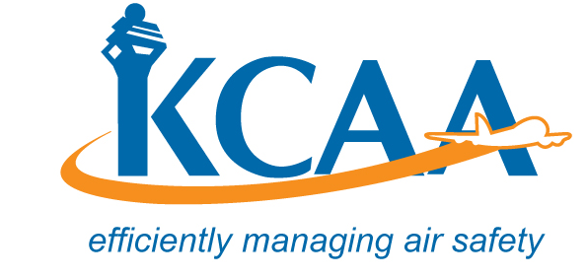 | Form: AC-AWS002A
Aircraft Equipment and System Installation Form CAA-AWS-002B and the Aircraft C of A Issue / Renewal Report Form CAA-AWS-002C Should be Filled and Submitted with this Application Form

